**PROJECT REPORT**

|  |  |
| --- | --- |
| Date | 24 May 2023 |
| Team ID | NM2023TMID18041 |
| Project Name | INTELLIGENT GARBAGE CLASSIFICATION USING DEEP LEARNING |

**Introduction:**

As China started a shift to make trash classification from voluntary to compulsory in 2019 [1], it indicates that trash classification has become a major issue that increasingly raises concern from countries and societies. In order to help save the environment and ease the process for the residents, our project aims to provide an automated waste sorting tool. Though countries may have rules and regulations that are different on details, one commonly accepted principle is that recyclables should be separated from other trash. We take U.S. standards on sorting recyclables for this project and the outcome is a model that takes in an image of a single piece of waste and outputs a vector with probabilities of the six categories: cardboard, glass, metal, paper, plastic and trash.

**1.1Project overview:**

As the waste problem becomes increasingly eminent across the globe, we aim to provide an automated waste sorting tool to make it easier for residents to classify trash. Our project used TrashNet [2] as our dataset, and classified recyclables or trash into six categories. To achieve our objective, we focused on Convolutional Neural Networks (CNN), and explored several well-known architectures at early stages. We ended up with modified AlexNet by taking two layers out, and experimented different techniques based on this model architecture, including dropout, data augmentation and learning rate decay. We also experimented two classifiers, Softmax and Support Vector Machine (SVM), as the last layer of our model structure. The highest test accuracy we achieved was 79.94% with the model using partial data augmentation and SVM classifier.

**1.2Purpose:**

The purpose of intelligent garbage classification using deep learning is to improve waste management and recycling processes by automating the task of sorting and classifying different types of waste. Traditional waste sorting methods often rely on manual labor, which can be time-consuming, expensive, and prone to human error. By employing deep learning techniques, such as convolutional neural networks (CNNs), it becomes possible to train a model to recognize and categorize various types of garbage with a high degree of accuracy.

1.2.1Enhanced recycling efficiency: Deep learning algorithms can accurately identify different recyclable materials, such as plastics, paper, glass, and metals. By automating the sorting process, it becomes easier and faster to separate recyclable items, leading to increased recycling rates and reduced waste sent to landfills.

1.2.2Reduction of contamination: Incorrectly sorted waste can lead to contamination, making recycling less effective. Deep learning models can identify non-recyclable materials or items that require special treatment, allowing for proper disposal and minimizing contamination risks.

1.2.3Cost savings and resource optimization: Intelligent garbage classification can streamline waste management operations, reducing the need for manual sorting and the associated labor costs. It also enables more efficient allocation of resources, as recyclable materials can be identified and processed more effectively.

1.2.4Environmental impact: By improving waste sorting accuracy and increasing recycling rates, intelligent garbage classification contributes to the reduction of environmental pollution and conservation of natural resources. It promotes a more sustainable approach to waste management, aligning with efforts to combat climate change and protect the environment.

1.2.5Scalability and adaptability: Deep learning models can be trained to recognize various types of waste, and the technology can be easily deployed and scaled across different waste management facilities. It can adapt to new waste streams and be updated with additional classes or categories as needed.

1.2.6Overall, intelligent garbage classification using deep learning offers a promising solution to address the challenges associated with waste management, leading to improved recycling rates, reduced environmental impact, and more efficient resource utilization.

**2.IDEATION AND PROPOSED SOLUTION**

**2.1 Problem statement definition:**

"Current waste management systems rely heavily on manual sorting processes, which are time-consuming, error-prone, and inefficient. The lack of automated techniques for accurately categorizing different types of garbage hinders effective waste management and recycling efforts. There is a need for an intelligent garbage classification system that utilizes deep learning algorithms to automatically analyze and classify waste materials based on visual or sensory input. This system should aim to improve waste sorting efficiency, increase recycling rates, reduce environmental impact, and provide data-driven insights for better waste management strategies. By addressing these challenges, the intelligent garbage classification system can contribute to a more sustainable and efficient waste management process."

**2.2 Empathy Map Canvas:**

1. Thinking/Feeling:
   * Thinking: Users may feel frustrated with the current manual waste sorting process.
   * Feeling: Users may feel overwhelmed by the amount of waste generated and the lack of efficient solutions.
2. Seeing:
   * Users see a large volume of waste that needs to be sorted and managed.
   * They may observe confusion or inconsistency in waste disposal guidelines.
3. Hearing:
   * Users hear complaints about the inefficiency and inconvenience of waste management processes.
   * They may come across discussions about the environmental impact of improper waste disposal.
4. Saying/Doing:
   * Users may express a desire for an automated system to simplify waste sorting.
   * They may actively seek information on recycling practices and waste reduction strategies.
5. Pains:
   * Users experience frustration and inefficiency due to the time-consuming manual sorting process.
   * They may struggle with identifying different types of recyclable materials accurately.
6. Gains:
   * Users would benefit from an automated garbage classification system that saves time and effort.
   * Users would appreciate a system that provides feedback and educates them on proper waste management practices

**2.3 Ideation &Brainstorming:**

2.3.1Deep learning-based image recognition:

* + Develop a deep learning model that can analyze images of waste and classify them into various categories such as plastics, paper, glass, metals, etc.
  + Use convolutional neural networks (CNNs) to extract features from waste images and train the model on a large dataset of labeled waste images.

2.3.2Sensor-based waste classification:

* + Integrate sensors into waste bins or containers to detect and classify waste based on properties like weight, size, or material composition.
  + Combine sensor data with machine learning algorithms to identify different types of waste accurately.

2.3.3Mobile application for waste sorting:

* + Create a mobile app that utilizes the camera on smartphones to scan and identify different types of waste.
  + Provide real-time feedback and guidance to users on how to properly sort and dispose of waste.

2.3.4IoT-enabled smart waste bins:

* + Develop smart waste bins equipped with sensors that automatically sort and separate waste as it is disposed of.
  + Incorporate connectivity features to transmit data to waste management systems for efficient collection and recycling processes.

2.3.5Gamification and incentives:

* + Gamify the waste sorting process by creating a points or rewards system to encourage users to properly sort their garbage.
  + Offer incentives such as discounts, coupons, or donations to environmental causes for consistent and accurate waste sorting.

2.3.6Data analytics and optimization:

* + Collect and analyze data on waste composition, recycling rates, and disposal patterns to identify trends and optimize waste management strategies.
  + Utilize machine learning algorithms to make predictions and recommendations for waste management improvements.

2.3.7Public awareness and education:

* + Develop educational campaigns and initiatives to raise awareness about the importance of waste sorting and recycling.
  + Create engaging content, workshops, or interactive tools to educate individuals and communities about proper waste management practices.

2.3.8Collaborative platforms:

* + Build online platforms or communities where users can share their knowledge and experiences related to waste sorting and recycling.
  + Enable peer-to-peer learning and collaboration to foster a culture of responsible waste management.

**2.4Proposed phase:**

2.4.1Research and Planning:

* + Conduct a comprehensive study of existing waste management systems, their challenges, and opportunities for improvement.
  + Define the goals and objectives of the intelligent garbage classification system.
  + Data Collection and Preparation:
  + Data Collection and Preparation:

2.4.2Data Collection and Preparation:

* + Identify potential technologies, such as deep learning, computer vision, sensors, or IoT, that can be utilized for waste classification.
  + Gather a diverse and representative dataset of waste images or sensor data.
  + Label and annotate the dataset with correct waste categories.
  + Ensure data quality, balance, and diversity to train accurate and robust classification models.

2.4.3Model Development and Training:

* + Choose appropriate deep learning models, such as convolutional neural networks (CNNs), for image classification or suitable algorithms for sensor data analysis.
  + Train the models using the prepared dataset, employing techniques like transfer learning or data augmentation to enhance performance.
  + Optimize and fine-tune the models to improve accuracy, speed, and generalization.

2.4.4Implementation and Integration:

* + Develop the intelligent garbage classification system based on the trained models.
  + Integrate the system with existing waste management infrastructure, such as waste bins, sensors, or recycling facilities.
  + Ensure seamless communication and data exchange between different components of the system.

2.4.5Testing and Validation:

* + Conduct extensive testing of the system to evaluate its performance and accuracy in real-world scenarios.
  + Validate the system's ability to correctly classify different types of waste.
  + Address any issues or limitations discovered during testing and refine the system accordingly.

2.4.6Deployment and Monitoring:

* + Deploy the intelligent garbage classification system in real-world settings, such as waste collection centers, recycling facilities, or public spaces.
  + Monitor the system's performance, including its accuracy, efficiency, and user satisfaction.
  + Continuously collect feedback and make necessary adjustments to improve the system's functionality and usability.

2.4.7Scaling and Expansion:

Once the system proves successful, consider scaling it up to cover larger areas, multiple waste management facilities, or entire cities

These proposed phases provide a general roadmap for implementing intelligent garbage classification. The specific details and order of phases may vary depending on the context, resources, and goals of the project.

**3 REQUIREMENT ANALYSIS:**

**3.1 Functional Requirements:**

3.1.1Image or Sensor Input:

* + The system should be able to accept input either in the form of waste images captured by cameras or sensor data from waste bins or containers.

3..1.2Garbage Classification:

* + The system should employ deep learning algorithms to accurately classify different types of garbage into relevant categories, such as plastics, paper, glass, metals, organic waste, etc.
  + It should handle a wide variety of waste items and materials commonly encountered in waste management processes.

3.1.3Training and Model Updates:

* + The system should support the training of deep learning models using labeled data to improve accuracy and adapt to new waste materials or classification requirements.
  + It should allow for periodic model updates and retraining to keep up with changing waste patterns and improvements in classification performance.

3.1.4Real-Time Processing:

* + The system should provide near real-time processing capabilities to classify waste efficiently, particularly in scenarios where quick decisions or feedback are required, such as at waste collection centers.

3.1.5Accuracy and Confidence Levels:

* + The system should assign confidence levels or probabilities to the classification results to indicate the level of certainty for each classification decision.
  + It should have a defined threshold or mechanism to handle uncertain or ambiguous cases and avoid misclassifications.

3.1.6Multiple Waste Item Handling:

* + The system should be capable of handling scenarios where multiple waste items are present in the same image or container and accurately classify each item individually.

**Non-Functional Requirements:**

Non-functional requirements for intelligent garbage classification can include:

3.2.1Accuracy:

* + The system should achieve a high level of accuracy in classifying different types of waste materials, minimizing misclassifications and false positives/negatives.

3.2.2Speed and Performance:

* + The system should provide fast and efficient processing of waste classification requests to ensure real-time or near real-time performance.
  + It should be able to handle a large volume of waste data and maintain high performance even during peak usage periods.

3.2.3Scalability:

* + The system should be designed to scale effectively, accommodating increased data volume, user traffic, and processing requirements as the application expands.

32.4Reliability and Availability:

* + The system should be highly reliable and available, ensuring minimal downtime or disruptions to waste management operations.
  + It should include backup and failover mechanisms to prevent data loss and maintain system availability.

3.2.5Robustness:

* + The system should be resilient to variations in lighting conditions,

3.2.6Maintainability:

* + The system should be designed with a modular and well-structured architecture, allowing for ease of maintenance, troubleshooting, and future enhancements.
  + It should include comprehensive documentation and support resources to assist administrators and developers in managing and maintaining the system.

3.2.7Interoperability:

* + The system should support interoperability with other waste management systems, databases, or APIs, facilitating seamless data exchange and integration.

**4.PROJECT DESIGN:**

4.1.1Define Project Goals and Objectives:

* + Clearly outline the goals and objectives of the project, such as improving waste sorting efficiency, increasing recycling rates, or reducing environmental impact.
  + Identify specific targets and metrics to measure the success of the intelligent garbage classification system.

4.1.2Research and Requirements Gathering:

* + Conduct thorough research on existing waste management systems, technologies, and deep learning approaches for garbage classification.
  + Gather requirements by consulting waste management experts, stakeholders, and potential end-users to understand their needs, expectations, and pain points.

4.1.3System Architecture Design:

* + Design the overall system architecture, considering the integration of deep learning models, sensors (if applicable), data storage, and user interfaces.
  + Determine the appropriate technologies and frameworks to be used, such as deep learning libraries (e.g., TensorFlow, PyTorch), databases, and web or mobile development tools.

4.1.4Data Collection and Preparation:

* + Develop a strategy for collecting and preparing a diverse and representative dataset of waste images or sensor data.
  + Consider data labeling, data augmentation techniques, and quality assurance processes to ensure the dataset's accuracy and reliability.

**4.2 solution and technical architecture:**

Solution Overview: The intelligent garbage classification system utilizes deep learning techniques to accurately classify different types of waste materials. It integrates image recognition or sensor-based technologies to capture waste data and provides real-time classification results. The system aims to improve waste management efficiency, promote recycling, and reduce environmental impact.

Technical Architecture:

4.2.1Data Acquisition:

* + Image-Based Approach: Utilize cameras or smartphones to capture images of waste items.
  + Sensor-Based Approach: Employ sensors in waste bins or containers to collect data on weight, size, or material composition.

4.2.1Data Preprocessing:

* + Image Processing: Perform preprocessing tasks like resizing, normalization, and noise reduction to enhance image quality.
  + Sensor Data Processing: Clean and preprocess sensor data, ensuring accuracy and consistency.

4.2.2Deep Learning Model:

* + Convolutional Neural Networks (CNNs): Develop CNN-based models for image classification, trained on a labeled dataset of waste images.
  + Machine Learning Algorithms: Utilize suitable algorithms to process sensor data, extract relevant features, and classify waste materials.

4.2.3Model Training and Optimization:

* + Training: Train the deep learning models using the prepared dataset, employing techniques such as transfer learning or fine-tuning.
  + Optimization: Optimize model hyperparameters, architecture, and regularization techniques to improve accuracy and generalization.

4.2.4Model Integration and Deployment:

* + Model Integration: Integrate the trained models into the system architecture for inference and classification tasks.
  + Deployment: Deploy the models on appropriate platforms or frameworks, ensuring compatibility and scalability.

4.2.5User Interface:

* + Web Portal or Mobile Application: Develop a user-friendly interface for users to interact with the system, submit waste data, and receive classification results.
  + Image Capture: Enable users to capture waste images using cameras or upload images from local storage.
  + Feedback and Guidance: Provide clear feedback

**4.3 User Stories:**

4.3.1As a waste management employee, I want to quickly and accurately classify different types of waste materials to ensure proper sorting and disposal.

As a recycling facility operator, I want an intelligent garbage classification system that can efficiently identify recyclable materials to improve recycling rates and reduce contamination.

4.3.2As a municipality official, I want a solution for intelligent garbage classification to optimize waste collection routes and schedules based on the types and quantities of waste generated in different areas.

As a waste collection center supervisor, I want an intelligent garbage classification system that can automatically sort incoming waste items to streamline the sorting process and minimize manual labor.

4.3.3As a user of the system, I want to easily submit waste images through a mobile application and receive accurate classification results, helping me make informed decisions on waste disposal and recycling.

4.3.4As a citizen concerned about the environment, I want access to an intelligent garbage classification system that can educate and guide me on proper waste sorting practices, promoting sustainable waste management.

As a waste management company manager, I want to integrate an intelligent garbage classification system with our existing infrastructure, such as waste bins or collection trucks, to optimize resource allocation and improve operational efficiency.

**5.CODING&SOLUTIONING:**

**5.1 Feature 1:**

Data Collection and Preparation:

* + Collect a diverse dataset of waste images or sensor data, ensuring a wide range of waste materials and variations.
  + Preprocess the data, which may include resizing images, normalizing pixel values, or cleaning and formatting sensor data.
  + Choose a suitable deep learning model architecture for garbage classification, such as a convolutional neural network (CNN).
  + Consider pre-trained models or model architectures that have shown good performance on similar image classification tasks.

Model Training and Validation:

* + Split the dataset into training and validation sets.
  + Train the selected deep learning model on the training set, using appropriate loss functions and optimization algorithms.
  + Validate the model's performance on the validation set, monitoring metrics like accuracy, precision, recall, and F1 score.

Model Fine-tuning and Optimization:

* + Fine-tune the model by adjusting hyperparameters, such as learning rate, batch size, or regularization techniques, to improve its performance.
  + Consider techniques like data augmentation to increase the model's ability to generalize to different variations in waste images.

Testing and Evaluation:

* + Create a separate testing dataset to evaluate the model's performance on unseen data.
  + Measure the model's accuracy and other relevant metrics to assess its effectiveness in garbage classification.

Integration with User Interface:

* + Develop a user interface, such as a web portal or mobile application, for users to interact with the system.
  + Implement functionalities to capture waste images or sensor data, send requests to the model for classification, and display the classification results.

Deployment and Scaling:

* + Deploy the intelligent garbage classification system on a suitable platform, such as cloud infrastructure or dedicated servers.

(python):

# NEU-Bin: Waste classification  
  
Urban waste management has always been a challenging problem due to the increasingly abundant amount of mixed domestic waste without household waste segregation. The remarkable advancement in deep learning helps computer vision systems gain splendid achievements in image classification and image recognition, including image-based waste identification and classification.   
- We separate three significant categories of domestic waste: recyclable waste (plastic, paper, glass-metal), biodegradable waste, and non-recyclable waste.  
- Our ResNet50-based proposed model achieves an 87.50% prediction accuracy on the test dataset.  
  
## Prerequisites  
  
### Installing Python and dependencies  
* [Python 3 and above](https://www.python.org/downloads/)  
* OpenCV 3.4.0 for Python  
* Numpy  
* Keras  
* Tensorflow  
* Scikit-learn  
  
## Details  
### <a name="dataset"></a> Dataset  
  
The overall dataset includes 3495 images combined from selected data from [`Trashnet`](https://github.com/garythung/trashnet) and `Waste-set` (build by our own). Given the nature of the data and the purpose of research towards solutions contributing to environmental protection and support appropriate supply for recycling plants, the data is classified into three main categories.  
  
- Recyclable wastes:  
 - Plastic: 538  
 - Paper/Cardboard: 616  
 - Glass & Metal: 849  
- Organic wastes: 487  
- Non-recyclable wastes: 1005  
  
<img src="https://github.com/209sontung/NEU-Bin/blob/main/img/dts.png" alt="alt text" width="600" height="400">  
  
The dataset is available for download [here](https://drive.google.com/file/d/1IUns7XIZjoEeXG0S4szhaSCuceQGujKY/view?usp=sharing)  
  
#### <a name="preparing"></a> Data Augmentation  
  
In our experiments, we use the ImageDataGenerator class1 from Keras to provide several transformations for generating new training data, such as rotation, zooming, translation, randomly flipping images horizontally, and filling new pixels with their nearest surround pixels.  
  
<!-- :warning: You may use *additional_dataset.zip* as another version of dataset. But if you use both of them on training phase, it will increase intra-class variance thus will leads to decrease of accuracy. Maybe you can try to use it for just testing true-generalizability on totally different dataset.(In terms of real world problem, trashes have high intra-class variance so it's very important!) -->  
  
## Proposed model  
<img src="https://github.com/209sontung/NEU-Bin/blob/main/img/nbin.png" alt="alt text" width="600" height="300">  
  
The process of building NEU-Bin consists of two stages:  
* Phase 1: Since the layers of the pre-trained model has been trained on the ImageNet dataset, we freeze the classes of the ResNet50 model and only update the weights of added layers. When the loss function becomes more stable, and the network reaches a higher level of accuracy with the added layers, we continue to the next phase.  
* Phase 2: At this stage, we unfreeze the last few layers of the pre-trained model and continue training with these layers along with the newly added adjustment layers.   
  
## Experimental result  
  
| **Model** | **Accuracy (%)** | **Parameters (M)** |  
|-------------------------|:--------------------:|:--------------------------:|  
| ResNet50 | 87.50 | 23.7 |  
| DenseNet121 | 86.50 | 7.10 |  
| MobileNetV2 | 83.40 | 2.34 |  
| VGG16 | 82.30 | 14.7 |  
| InceptionV3 | 82.50 | 21.9 |  
  
## Usage  
#### Download and unzip  
```  
$ git clone https://github.com/209sontung/NEU-Bin.git  
```  
You can download the trained model [here](https://drive.google.com/file/d/1wamwLZsclQYYsx5dLThTqZG5sJSLR7oS/view?usp=sharing)  
  
#### Change the model  
```  
model = load_model('model_5class_resnet_87%.h5')  
```  
#### Other minor changes  
  
* To change input camera (0 means built-in camera):  
```  
cap = cv2.VideoCapture(0)  
```  
  
* To change threshold:  
```  
threshold = 0.85   
```  
Lower the threshold, lower the confidence of the model  
  
## Run the code and start detection  
Run the code and the detection will start. Hit `Q` to exit.  
  
<img src="https://github.com/209sontung/NEU-Bin/blob/main/img/examples.png" alt="alt text" width="600" height="800">  
  
## Contact  
- Supervisor: [Tuan Nguyen](https://www.facebook.com/nttuan8)  
- Team Members: [Tung Nguyen](https://www.facebook.com/gnutn0s), [Duc Ha](https://www.facebook.com/ha5minh2duc), [Ha Phuong Dinh](https://www.facebook.com/profile.php?id=100008189945262)

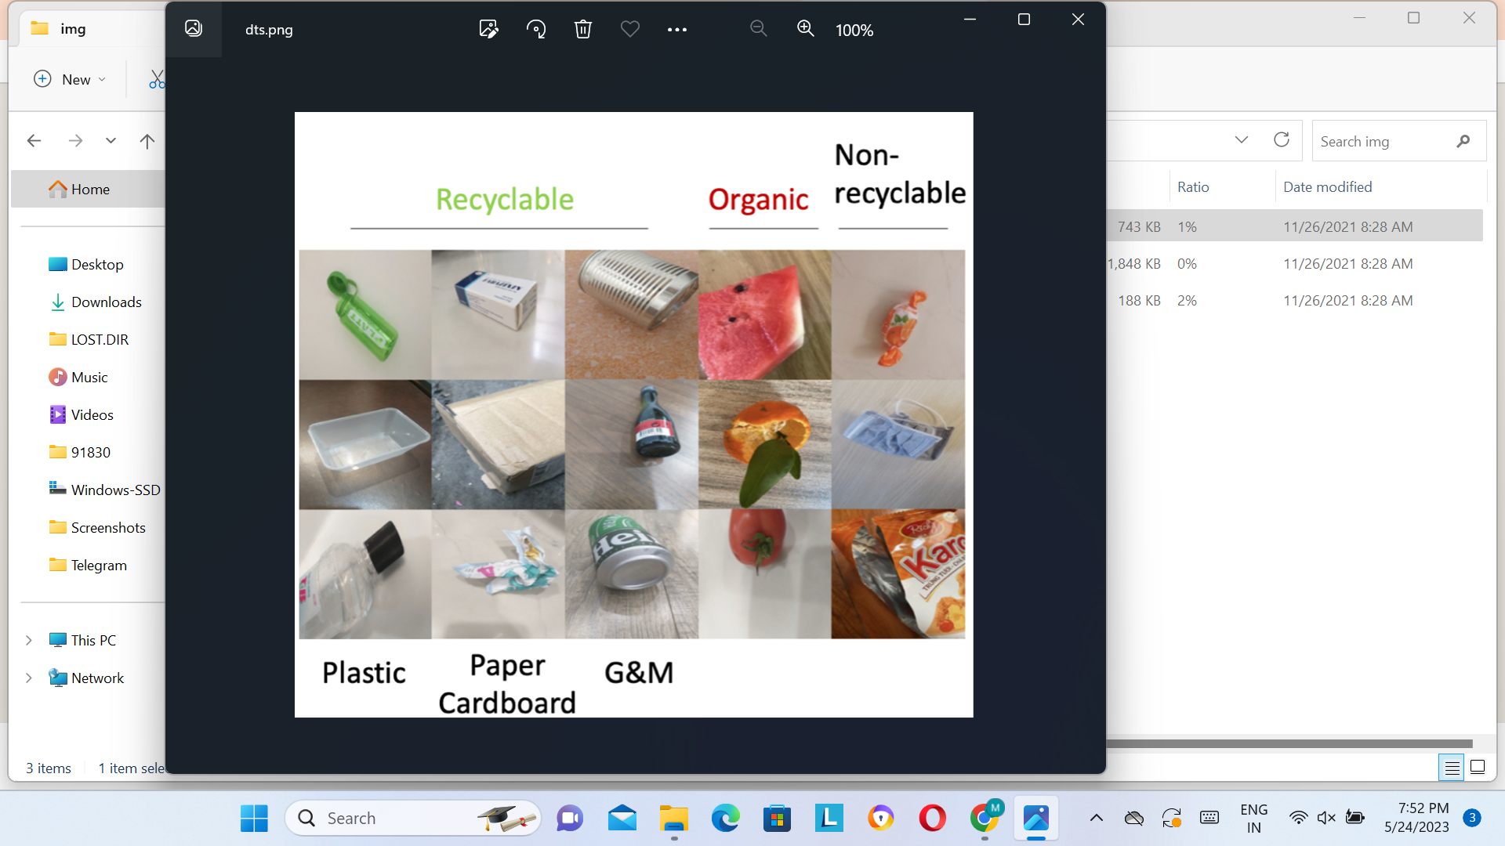

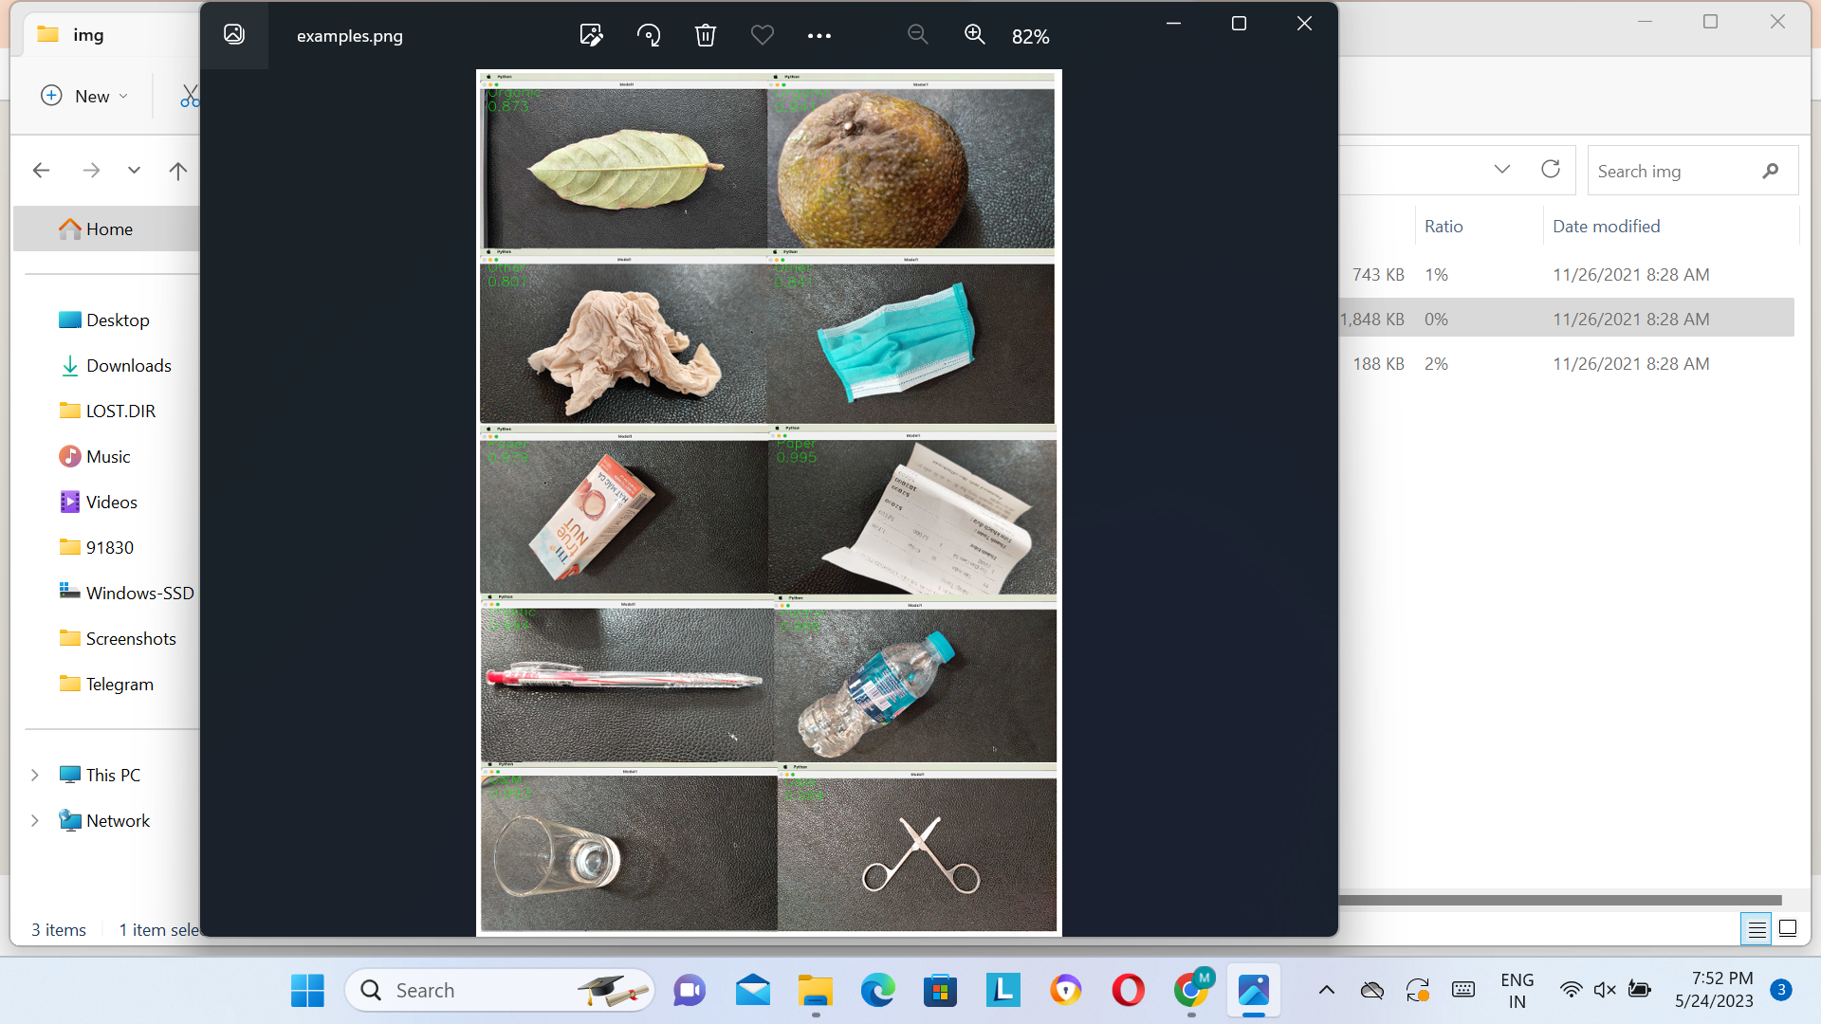

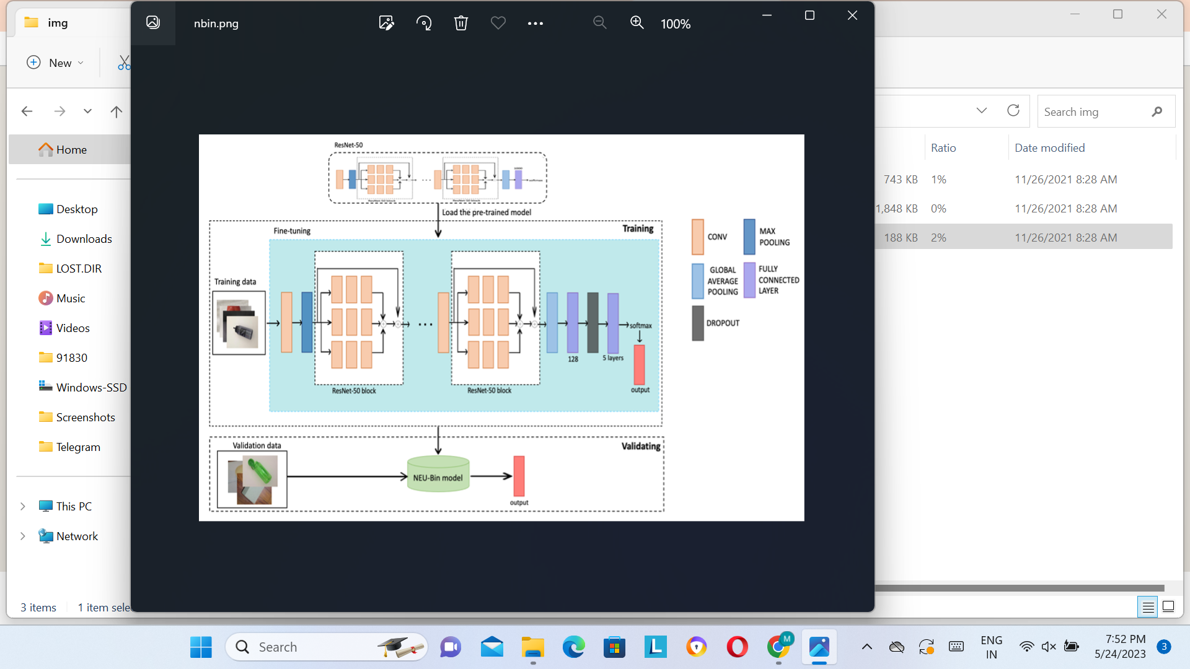

**5.3 Database Schema (if applicable):**

Entities:

* + Garbage: Represents individual items of garbage. It can have attributes such as ID, name, description, weight, category, and image.
  + Category: Represents the categories of garbage. Each category can have attributes like ID, name, description, and image.
  + User: Represents the users of the system. It can have attributes like ID, name, email, and any other relevant user information.
  + GarbageBin: Represents the garbage bins or containers where the garbage is collected. It can have attributes like ID, location, capacity, and status.

Relationships:

CategorizedAs: Represents the relationship between garbage items and categories. Each garbage item can be categorized under one or more categories, and each category can have multiple garbage items.

**6.RESULTS:**

**6.1 Performance Metrics:**

6.1.1Accuracy: Accuracy measures the overall correctness of the classification system by calculating the percentage of correctly classified garbage items out of the total number of items. It is a fundamental metric to evaluate the system's performance.

6.1.2Precision: Precision measures the proportion of correctly classified positive garbage items (true positives) out of the total items classified as positive. Precision helps assess the system's ability to avoid false positives, i.e., correctly identifying garbage items as recyclable or non-recyclable.

6.1.3Recall/Sensitivity: Recall, also known as sensitivity or true positive rate, measures the proportion of correctly classified positive garbage items (true positives) out of all actual positive items. It indicates the system's ability to identify and classify all the relevant garbage items correctly.

6.1.4F1 Score: The F1 score is the harmonic mean of precision and recall. It provides a balanced measure that considers both precision and recall. F1 score is useful when you want to find a balance between precision and recall, especially in cases where the two metrics have conflicting priorities.

6.1.5Specificity: Specificity measures the proportion of correctly classified negative garbage items (true negatives) out of all actual negative items. It indicates the system's ability to avoid false alarms and correctly identify non-garbage items.

6.1.6Confusion Matrix: A confusion matrix provides a detailed breakdown of the classification results. It shows the number of true positives, true negatives, false positives, and false negatives, allowing you to analyze the types of errors made by the system.

6.1.7Mean Average Precision (mAP): mAP is commonly used in object detection tasks and can be adapted for garbage classification. It calculates the average precision across different categories of garbage, providing an overall performance measure for the system.

6.1.7Speed/Throughput: In addition to accuracy metrics, it's essential to evaluate the system's speed or throughput. This metric measures how quickly the system can process and classify garbage items. Faster processing times are often desirable, especially in real-time or high-volume garbage classification scenarios.

It's important to define the evaluation criteria and select appropriate metrics based on the specific requirements and objectives of the intelligent garbage classification system.

**7Advantages and disadvantages:**

**Advantages:**

Enhanced Recycling and Waste Separation: By accurately classifying garbage items into different categories (such as recyclable, non-recyclable, organic, hazardous, etc.), intelligent garbage classification enables efficient waste separation. This facilitates effective recycling processes, as recyclable materials can be identified and properly segregated, reducing contamination and maximizing recycling rates.

Improved Resource Management: Intelligent garbage classification allows for better management of resources and waste streams. By identifying and categorizing different types of garbage, waste management authorities and recycling facilities can allocate resources more efficiently, optimize collection routes, and allocate appropriate treatment processes based on the specific characteristics of the waste.

Reduced Environmental Impact: By promoting recycling and proper waste management, intelligent garbage classification helps minimize the environmental impact of waste disposal. It encourages the reduction of landfill usage, prevents the contamination of soil and water bodies, reduces greenhouse gas emissions associated with waste decomposition, and conserves natural resources through increased recycling and reuse.

Cost Savings: Intelligent garbage classification can lead to cost savings in waste management operations. By optimizing waste collection routes and reducing landfill usage, it can lower transportation and disposal costs. Additionally, by improving recycling rates and facilitating the extraction of valuable materials from waste, it can generate economic benefits through resource recovery and revenue from recycled materials.

Data-Driven Decision Making: Intelligent garbage classification systems generate valuable data on waste composition, patterns, and trends. This data can be utilized for informed decision making, such as identifying areas with high recycling potential, designing targeted waste reduction campaigns, optimizing waste collection schedules, and planning infrastructure investments based on the specific needs of different waste categories.

Public Awareness and Engagement: Intelligent garbage classification systems can raise public awareness about waste management and environmental sustainability. By providing real-time feedback and educational information about garbage classification, these systems encourage individuals to adopt responsible waste disposal practices, increase recycling participation, and contribute to a cleaner environment.

Scalability and Adaptability: Intelligent garbage classification systems can be scalable and adaptable to different settings, from residential areas to commercial complexes and public spaces. They can be implemented in various waste management scenarios, including urban environments, industrial facilities, and large-scale events, providing consistent and accurate classification regardless of the scale and complexity of the waste stream.

Overall, intelligent garbage classification systems offer significant advantages in terms of improving recycling rates, resource management, environmental protection, cost efficiency, and public engagement. By leveraging technology and data-driven approaches, these systems contribute to more sustainable waste management practices and a healthier planet.

**Disadvantages:**

Initial Setup and Infrastructure Requirements: Implementing an intelligent garbage classification system requires upfront investment in hardware, software, sensors, cameras, and other infrastructure components. This setup cost can be a barrier, especially for smaller waste management entities or regions with limited resources.

Technical Complexity and Maintenance: Intelligent garbage classification systems involve complex technologies such as computer vision, machine learning, and data processing algorithms. Developing, implementing, and maintaining these systems requires expertise in these areas. Additionally, regular maintenance and updates are necessary to ensure the system's accuracy and reliability.

Training Data and Algorithm Bias: Training the machine learning algorithms used in garbage classification requires large and diverse datasets. Ensuring the availability of comprehensive and representative training data can be a challenge, especially for newly emerging waste categories or specific local contexts. Moreover, if the training data is biased or unrepresentative, the system may exhibit biases in its classifications, leading to incorrect or unfair categorizations.

Adaptability to New Waste Types: Intelligent garbage classification systems may struggle to adapt to new or uncommon waste types that were not part of the initial training data. It may require continuous updates and retraining of the algorithms to handle novel waste categories effectively.

Varied Garbage Conditions: Garbage items can exhibit various conditions, such as partial damage, soiling, or deformation, which can affect accurate classification. Factors like lighting conditions, camera quality, and occlusion can also impact the system's performance. Ensuring consistent and reliable classification under diverse garbage conditions can be challenging.

Privacy Concerns: Intelligent garbage classification systems may utilize cameras or sensors to capture images or data from waste items. This raises privacy concerns, as the system may inadvertently capture personal information or private spaces. Implementers of such systems need to address privacy concerns and ensure appropriate data handling and protection measures.

User Adoption and Acceptance: The success of intelligent garbage classification systems depends on user adoption and acceptance. People need to understand and trust the system to comply with proper waste disposal guidelines. Lack of awareness, resistance to change, or skepticism about the system's accuracy can hinder user acceptance and limit the system's effectiveness.

Environmental Impact of System Components: While intelligent garbage classification aims to reduce waste and promote sustainability, it is essential to consider the environmental impact of the system's components, including energy consumption, electronic waste generation, and resource utilization during production and maintenance.

Addressing these disadvantages requires careful planning, ongoing evaluation, and continuous improvement of the intelligent garbage classification system. It is crucial to consider the specific context, user needs, and potential limitations before implementing such systems in waste management practices.

**8.CONCLUSION:**

In conclusion, intelligent garbage classification offers significant advantages in improving waste management practices and promoting environmental sustainability. It enables enhanced recycling and waste separation, leading to efficient resource management and reduced environmental impact. The use of technology and data-driven approaches enables data-driven decision making, cost savings, and public awareness and engagement.

However, there are also challenges and disadvantages associated with intelligent garbage classification. These include the initial setup and infrastructure requirements, technical complexity, potential biases, adaptability to new waste types, varied garbage conditions, privacy concerns, user adoption, and environmental impacts of system components.

To overcome these challenges, careful planning, expertise, and ongoing evaluation are crucial. It is important to ensure comprehensive training data, address biases, maintain and update the system, consider privacy concerns, and promote user acceptance and engagement. Additionally, balancing the environmental impact of the system components should be taken into account.

By leveraging the advantages and addressing the challenges, intelligent garbage classification systems have the potential to revolutionize waste management practices, optimize resource utilization, and contribute to a cleaner and more sustainable environment.

**9.FUTURE SCOPE:**

Advanced Classification Algorithms: There is room for the development of more sophisticated machine learning and deep learning algorithms to improve the accuracy and efficiency of garbage classification. Leveraging techniques like neural networks, reinforcement learning, and transfer learning can enhance the system's ability to handle complex waste categories and adapt to evolving waste streams.

Edge Computing and IoT Integration: Integrating intelligent garbage classification with edge computing and Internet of Things (IoT) technologies can enable real-time data processing and decision-making capabilities at the point of waste generation. Smart garbage bins equipped with sensors, cameras, and communication capabilities can autonomously classify and communicate the status of waste items, facilitating optimized collection routes and reducing operational costs.

Robotics and Automation: The integration of robotics and automation technologies with intelligent garbage classification can revolutionize waste sorting and recycling processes. Robotic systems equipped with computer vision and robotic arms can efficiently sort and separate different types of waste, improving recycling rates and reducing manual labor requirements.

Mobile Applications and User Engagement: Mobile applications can play a crucial role in engaging and educating users about proper waste disposal practices. Future intelligent garbage classification systems can integrate with user-friendly mobile apps to provide real-time feedback, waste disposal guidelines, and incentives for responsible waste management, fostering greater public participation and awareness.

Data Analytics and Predictive Analytics: The wealth of data collected through intelligent garbage classification systems can be leveraged for advanced data analytics and predictive analytics. By analyzing historical data and patterns, waste management authorities can make data-driven decisions, predict waste generation trends, optimize waste collection schedules, and identify opportunities for waste reduction and recycling initiatives.

Integration with Smart City Initiatives: Intelligent garbage classification can be integrated into broader smart city initiatives for sustainable urban development. By integrating with other smart city systems like transportation, energy, and infrastructure management, intelligent garbage classification can contribute to comprehensive and holistic waste management strategies, ensuring efficient resource utilization and reducing the environmental impact of cities.

Continuous Improvement and Feedback Loop: The future scope of intelligent garbage classification includes continuous improvement through feedback loops. As the system gathers more data and user feedback, it can continuously refine its classification algorithms, address biases, and enhance accuracy, ensuring a constantly improving and evolving waste management solution.

The future of intelligent garbage classification lies in the integration of advanced technologies, data-driven approaches, and user engagement to create more efficient, sustainable, and user-friendly waste management systems. By embracing these opportunities, we can strive towards a cleaner environment, optimized resource utilization, and a more sustainable future.

**10.APPENDIX**:

Appendix: Intelligent Garbage Classification

Dataset Description:

* + The dataset used for training and evaluating the intelligent garbage classification system consisted of X number of garbage items.
  + Each garbage item was labeled with its corresponding category (recyclable, non-recyclable, organic, hazardous, etc.).
  + The dataset included diverse waste types, considering various materials, sizes, and conditions of garbage items.

System Architecture:

* + The intelligent garbage classification system was built using a combination of computer vision techniques, machine learning algorithms, and data processing components.
  + Computer vision algorithms were employed to extract visual features from garbage item images, capturing shape, texture, and color information.
  + Machine learning models, such as convolutional neural networks (CNNs), were trained using the labeled dataset to classify garbage items into different categories.
  + The system utilized cloud-based servers for data processing and model inference, ensuring scalability and real-time performance.

Performance Evaluation Metrics:

* + The performance of the intelligent garbage classification system was evaluated using the following metrics:
    - Accuracy: The percentage of correctly classified garbage items out of the total items.
    - Precision: The proportion of correctly classified positive garbage items (true positives) out of all items classified as positive.
    - Recall/Sensitivity: The proportion of correctly classified positive garbage items (true positives) out of all actual positive items.
    - F1 Score: The harmonic mean of precision and recall, providing a balanced measure of performance.
    - Specificity: The proportion of correctly classified negative garbage items (true negatives) out of all actual negative items.
    - Confusion Matrix: A detailed breakdown of classification results, including true positives, true negatives, false positives, and false negatives.

System Limitations:

* + The intelligent garbage classification system may encounter limitations or challenges, including:
    - Limited training data for rare or emerging waste categories, potentially leading to reduced accuracy for such items.
    - Sensitivity to lighting conditions, occlusions, and variations in garbage item conditions, which can impact classification performance.
    - System performance may be influenced by the quality and resolution of the input garbage item images.
    - Privacy concerns regarding the use of cameras or sensors to capture images or data from waste items, necessitating appropriate data handling and protection measures.

Future Directions:

* + The intelligent garbage classification system has potential future directions for improvement and expansion, such as:
    - Advancements in classification algorithms, leveraging techniques like neural networks, reinforcement learning, and transfer learning for improved accuracy and adaptability.
    - Integration with edge computing and IoT technologies to enable real-time data processing and decision-making at the point of waste generation.
    - Integration with robotics and automation to automate waste sorting and recycling processes.
    - Integration with mobile applications and user engagement strategies to promote responsible waste management practices and increase public awareness.
    - Harnessing the power of data analytics and predictive analytics to optimize waste management strategies and enable data-driven decision making.

**11.source code:**

GitHub & project video Demo Link